Instruction:
Complete all questions in 1 hour.
1. Draw the logic diagram of the following gates using logsim and complete the truth tables.
a) AND
A | B | A.B

[Insert your gif image here]
b) NOR (do the same as in Q No. a for all of the following.)
c) OR
d) NAND (using NOT and AND)
e) XOR using AOI
2. Use LogSim to build the equivalent circuit for the following Boolean equations. Prove that the expressions are equivalent by computing truth table.
! (A + B) =! A . ! B
A | B | !(A + B) | !A . !B

[Insert your gif image here]

3. Draw the following circuit for the half adder using LogSim.
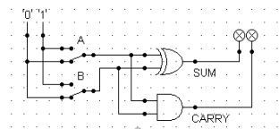
4. Draw full adder using Logsim and construct truth table.
5. Draw the logic circuit for the following Boolean equations using logsim simulator. a. AB+C
b. A(B+C)
c. X’Y’Z’

